

IOT ROBOT

MAJOR PROJECT REPORT

*By*

Vatsal shah

Roll No: IU1241090055

Department of Electronics & Communication Engineering

Indus Institute of Technology and Engineering

Ahmedabad

May 2016

**BONAFIDE CERTIFICATE**

This is to certify that this project report entitled **IOT ROBOT** submitted to **Department of Electronics and Communication Engineering, IITE, Ahmedabad**, is a bonafide record of work done by **VATSAL SHAH** under my supervision from

**January 1st, 2016** to **May 15th, 2016**.

………………………..

Abhishek Vaghela

Assistant Professor

………………………..

R N Mutagi

Head of Department

Electronics & Communication Department

Place :

Date :

**Declaration by Author**

This is to declare that this report has been written by me. No part of the report is plagiarized from other sources. All information included from other sources have been duly acknowledged. I aver that if any part of the report is found to be plagiarized, I shall take full responsibility for it.

………………………..

VATSAL SHAH

IU1241090055

Place :

Date :

ABSTRACT

The purpose of this project is to control robot with an interface board of the Raspberry Pi, sensors and software to full fill real time requirement. Controlling DC motors, different sensors, camera interfacing with raspberry Pi using GPIO pin. Live streaming, Command the robot easily, sends data of different sensors which works automatically or control from anywhere at any time. Design of the website and control page of Robot is done using Java tools and HTML. This system works on IoT concept which is Internet of Things, where all the physical devices will connect with digital systems. This will enable raspberry pi to be used for more robotic applications and cut down the cost for building an IoT robot.

**TABLE OF CONTENTS**

**Particulars Page No. Page No.**

Chapter-1 Introduction 1

**1.1 Background/Motivation 1**

**1.2 Aims & Objectives 1**

**1.3 Technology 1**

**1.4 Organization 1**

**1.4.1 Chapter 1: Introduction 2**

**1.4.2 Chapter 2: Design Methodology 2**

**1.4.3 Chapter 3: Implemented System 2**

**1.4.4 Chapter 4: Software Implementation 2**

**1.4.5 Chapter 5: Results 2**

**1.4.6 Chapter 6: Discussion / Conclusions / Future Work 2**

Chapter-2 Design Methodology 3

**2.1 Raspberry pi 2 4**

**2.1.1 Processor / SoC (System on Chip) 5**

**2.1.2 Power source 5**

**2.1.3 SD Card 5**

**2.1.4 GPIO – General Purpose Input Output 5**

**2.1.5 DSI Connector 5**

**2.1.6 RCA Video 6**

**2.1.7 Audio Jack 6**

**2.1.8 Status LEDs 6**

**2.1.9 USB 2.0 Port 7**

**2.1.10 Ethernet 7**

**2.1.11 CSI connector 7**

**2.1.12 JTAG headers 7**

**2.1.13 HDMI – High Definition Multimedia Interface 7**

**2.2 WiFi Dongle 7**

**2.3 Raspberry Pi Camera 7**

**2.4 5V Adapter Power Supply 8**

**2.5 Ultrasonic Sensor 8**

**2.6 IR Sensor 9**

**2.7 DC Motor 9**

**2.8 L293D Motor Driver IC 9**

**2.9 Specifications of Different Raspberry PI Model 10**

**2.10 Comparison of Raspberry with the competitors 11**

**2.11 Advantages and disadvantages 11**

**2.11.1 Advantages of the Raspberry Pi 11**

**2.11.2 Disadvantages 12**

Chapter-3 Software Implementation 13

**3.1 Eclipse Kepler 13**

**3.2 HTML/CSS 13**

**3.3 JSP/Servlet 13**

**3.4 Java Script 13**

**3.5 jQuery 14**

**3.7 MySQL 14**

**3.8 Pi4j 14**

**3.9 Debian Raspberry PI Language 14**

**3.10 Apache Tomcat 14**

**3.11 Linux 15**

**3.12 WinSCP 15**

**3.13** **MobaXterm 15**

**3.14 Putty 15**

Chapter-4 Implemented System 16

Chapter-5 Results 17

**5.1 Flow Chart 17**

**5.1 Display of Website 18**

Chapter-6 Discussion / Conclusion / Future Work 20

**6.1 Discussion 20**

**6.2 Conclusions 20**

**6.3 Future Work 21**

References 22

**LIST OF TABLES**

**Table 2 No & Item included of Block Diagram 3**

**Table 2.8 Behaviours of motor for different input conditions 10**

**Table 2.9 Specifications of Raspberry Pi different model 10**

**Table 2.10 Comparison of RPi with chief competitors 11**

**Table 5.2 Result set 19**

**LIST OF FIGURES**

**Figure 2.1 The initial block diagram for Remote Controlled Robot cam with RPi 3**

**Figure 2.1 Raspberry Pi B+ model 4**

**Figure 2.1.1 Structure of Raspberry Pi B+ model 4**

**Figure 2.1.4 GPIO connector on RPi 5**

**Figure 2.1.6 RCA Video Connector 6**

**Figure 2.1.8 Status LEDs 6**

**Figure 2.2 WiFi Dongle 7**

**Figure 2.3 Raspberry Pi Camera 8**

**Figure 2.4 5V Power Supply adapter 8**

**Figure 2.5 Ultrasonic Module 8**

**Figure 2.6 IR Sensor 9**

**Figure 2.7 DC Motor 9**

**Figure 2.8 Pin configuration of L293D 10**

**Figure 2.8.1 Screenshot of DC motor and L293D IC interfacing circuit 10**

**Figure 3.1 Eclipse 13**

**Figure 3.2 HTML 13**

**Figure 3.2.1 CSS 13**

**Figure 3.3 JSP/Servlet 13**

**Figure 3.4 JavaScript 13**

**Figure 3.5 jQuery 14**

**Figure 3.6 Ajax 14**

**Figure 3.7 MySql 14**

**Figure 3.8 Pi4j 14**

**Figure 3.9 Debian 14**

**Figure 3.10 Apache Tomcat 14**

**Figure 3.11 Linux 15**

**Figure 3.12 WinSCP 15**

**Figure 3.13 MobaXterm 15**

**Figure 3.14 Putty 15**

**Figure 4.1 Laser cut Chassis 16**

**Figure 4.1.1 3D printed Case 16**

**Figure 5.1 Flow Chart to Control Robot 17**

**Figure 5.2 Login Page for Robot Control 18**

**Figure 5.2.1 Control page of Robot Control 18**

**Figure 5.2.2 IOT Robot Structure 18****9**

Chapter-1 Introduction

The research and development of raspberry pi controlled IoT based robot. It works as buddy or family member. IoT is Internet of thing where all the physical devices connects with digital systems, such as Refrigerator, TV, AC, Washing machine, Music system which can works automatically or control from anywhere. Data says by 2020 50 billions device will connect. Raspberry Pi is a credit-card sized computer. It is connected with the Internet and robot can be control as per my command.

## **Background/Motivation**

User can see live streaming from computer device as website or phone application as camera is attached. Different buttons are there such as Forward, Reverse, Left, Right and Stop to control the Robot. Different sensors are attached with the device such as Ultrasonic sensor, IR sensors to detect obstacle and distance and generate notifications and sends data to user. In smart home concepts it can add value in it.

Security is always important at all the time, so there is unique login ID and password to control the Robot. First user have to sign up and using unique ID they will able to control it from anywhere at any time.

* 1. **Aims & Objectives**

To develop an IoT technology based Robot can be controlled by a mobile devices/ Laptops over the Wi-Fi from anywhere at any time.

The core objectives are:

* Gather system requirements
* Evaluate and study the platform required for the system
* Evaluate and study suitable development language, technologies and tools
* Evaluate Methods of Interface
* Program Raspberry Pi
* Interface board for dc motors
* Program Website & Control Page
* Evaluate and test the system
* Maintain system
  1. **Technology**

The technology used in the project is Javas the libraries available are only in pi4j. Also it allows creating a user interface so that the user can see and control certain movements of the robot. We use the wireless technology to transmit data of the raspberry pi to the users system.

* 1. **Organization**

This project is been divided into five chapters mainly as follows:

* + 1. **Chapter 1: Introduction**

In this section it gives a general idea of the project and also about the Aims and objectives of this project.

* + 1. **Chapter 2: Design Methodology**

This section contains information of the block diagram of the project and described each components in the detail part.

* + 1. **Chapter 3: Implemented System**

This chapter contains information about the software tools required for the carrying out of the project

* + 1. **Chapter 4: Software Implementation**

In this the hardware tools and the software tools required for the carrying out of the project is been specified also the interface designs for the project are also discussed.

* + 1. **Chapter 5: Results**

This chapter contains the test results of what has been done and what more of the objectives could have been achieved.

* + 1. **Chapter 6: Discussion / Conclusions / Future Work**

This chapter contains the discussion, conclusion and the future work of the project.

Chapter-2 Design Methodology

The design consists more on actual planning of hardware part than the code to be created. A number of software and hardware implementation techniques were used to design and develop the system. Fig. 1 shows the block diagram of system.

This section can be divided into many parts: Raspberry pi controller, Wifi dongle, Camera design, Power supply adapter, Ultrasonic sensor, IR sensors, and Motor control design. Block diagram is shows as below:

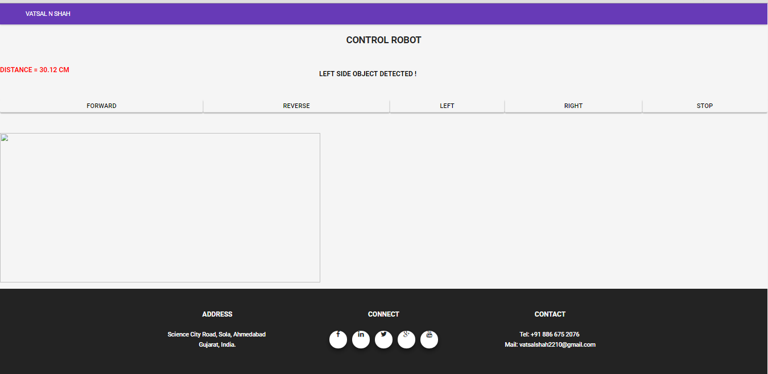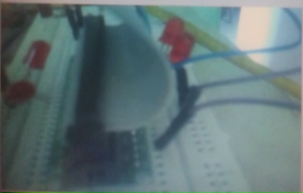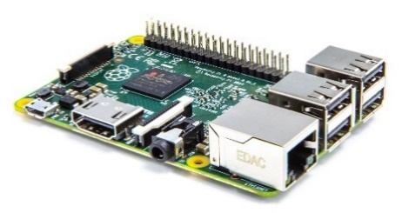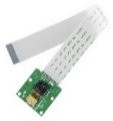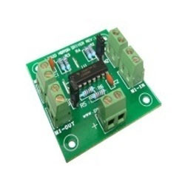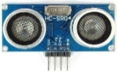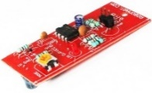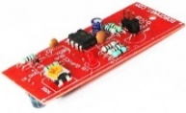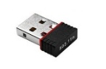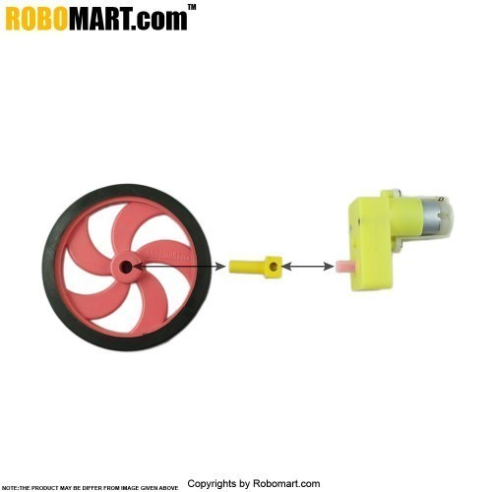

1

2

5

9

3

6

7

8

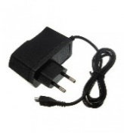

4

10

**Server**

(Raspberry Pi)

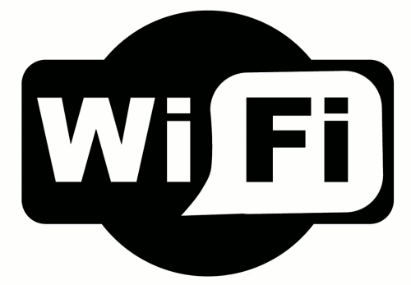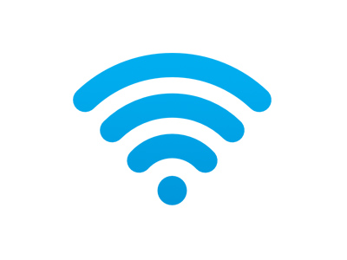

**Client**

(Browser on any device connected to the same WiFi network as the Raspberry Pi)

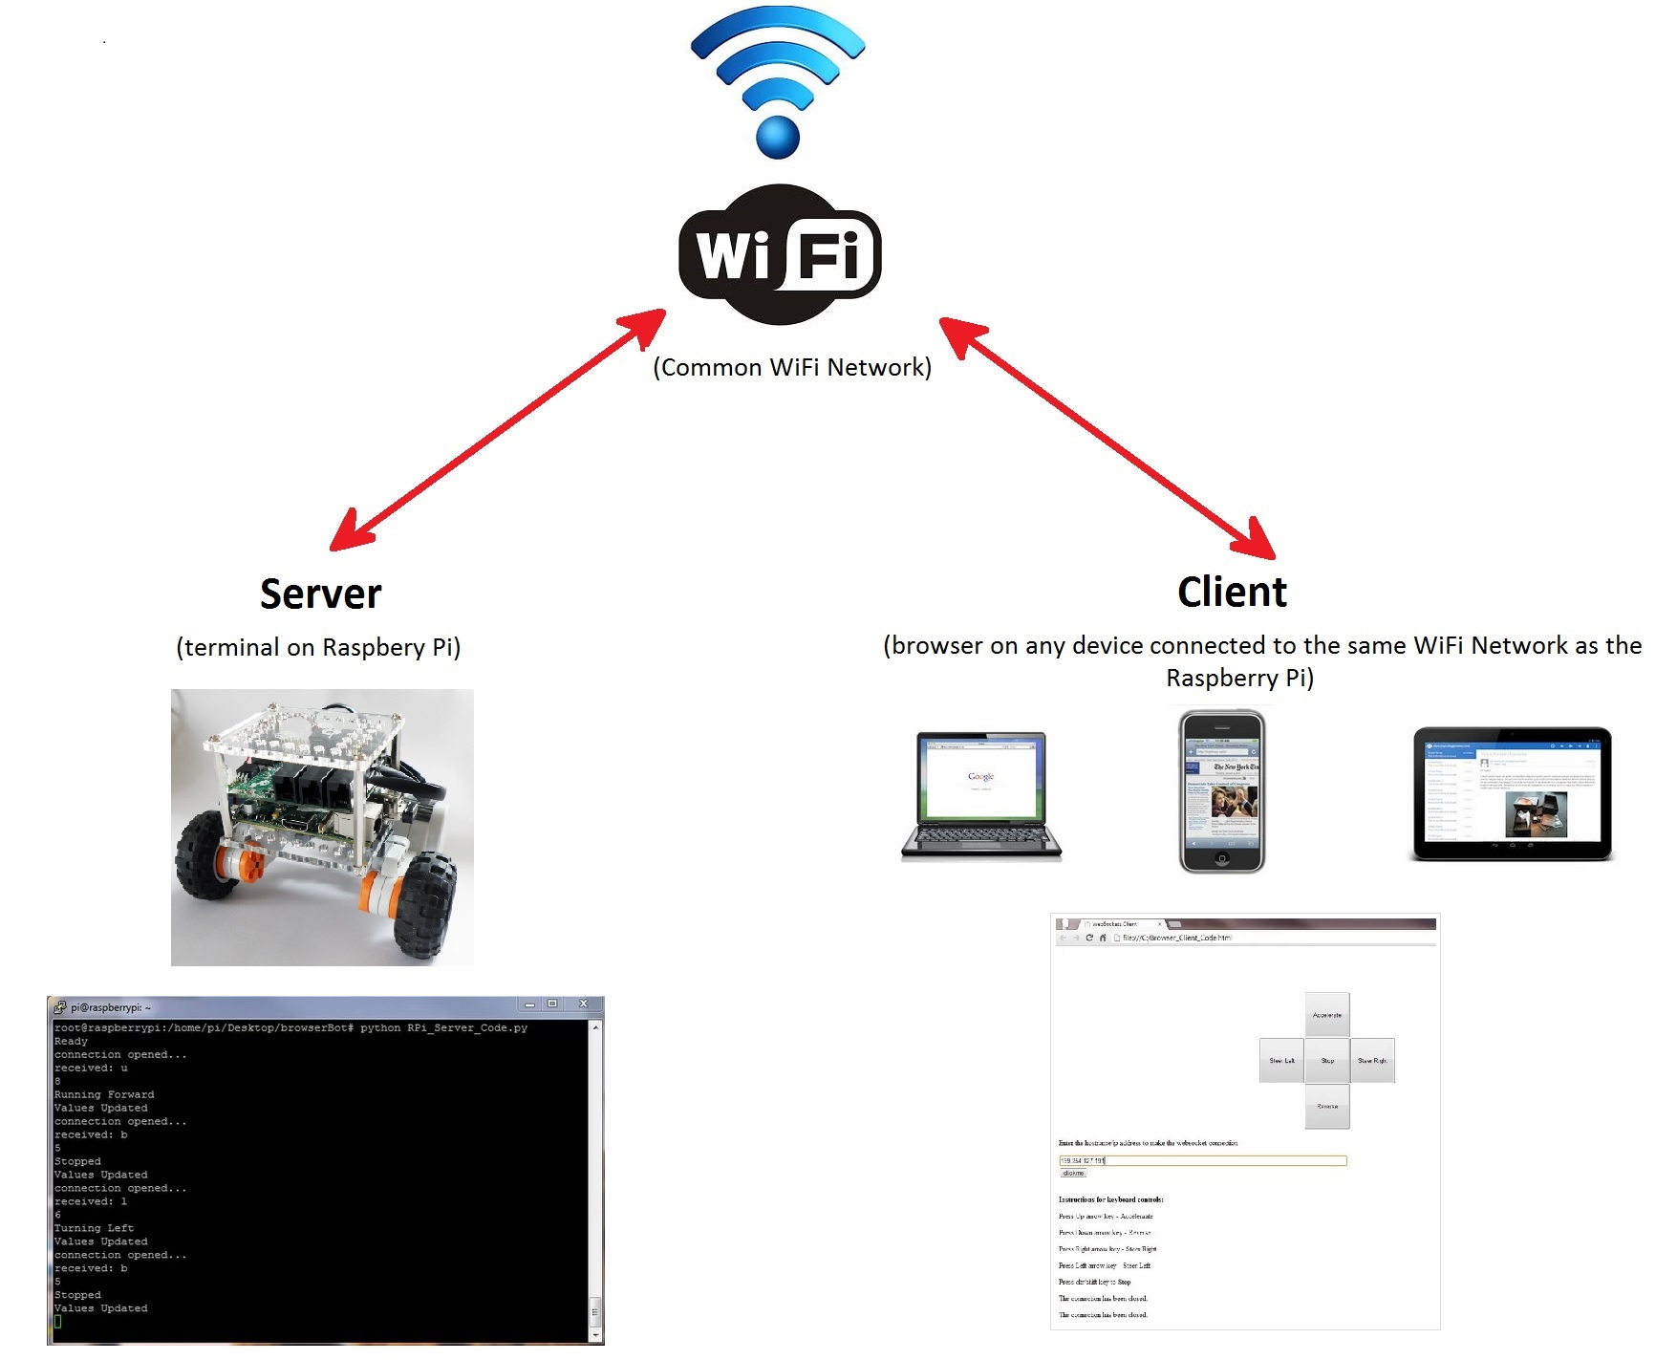

**Figure 2 The initia block diagram for IOT Robot**

**Block diagram numbering are shown as below:**

|  |  |  |  |
| --- | --- | --- | --- |
| No. | Item | No. | Item |
| 1 | Raspberry Pi 2 | 6 | IR Sensors |
| 2 | Wifi Dongle | 7 | Left Side DC Motor |
| 3 | Raspberry Pi Camera | 8 | Right Side DC Motor |
| 4 | 5V Adapter | 9 | L293D Motor Driver Board |
| 5 | Ultrasonic Sensor | 10 | 9V Battery |

**Table 2 No & Item included of Block Diagram**

**Components Details:**

Different components of block diagram is described in details below.

1. **Raspberry pi 2**

The Micro SD card is used for installing OS and the complete project will be done with python coding. The board has specification:

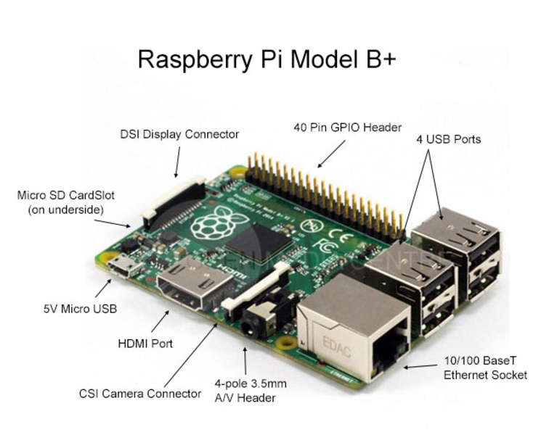

**Figure 1.1 Raspberry Pi B+ model**

|  |  |
| --- | --- |
| A 900MHz quad-core ARM Cortex-A7 CPU | 4 USB ports |
| 1GB RAM | Full HDMI port |
| 40 GPIO pins | Display Interface |
| Ethernet Port | Micro SD card Slot |
| Combined 3.5mm audio jack and composite video | Video core IV 3D graphics core |
| Camera Interface |  |

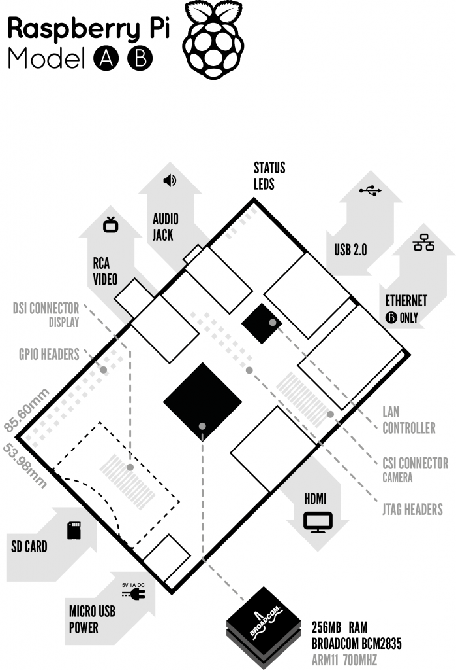

**Figure 2.1.1 Structure of Raspberry Pi B+ model**

**A brief description of the components on the Pi.**

* + 1. **Processor / SoC (System on Chip)**

The Raspberry Pi has a Broadcom BCM2835 System on Chip module. It has an ARM1176JZF-S processor. The Broadcom SoC used in the Raspberry Pi is equivalent to a chip used in an old smartphone (Android or iPhone). The Raspberry Pi chip operating at 700 MHz by default, will not become hot enough to need a heat sink or special cooling.

* + 1. **Power source**

The Pi is a device which consumes 700mA or 3W or power. It is powered by a MicroUSB charger or the GPIO header. Any good smartphone charger will do the work of powering the Pi.

* + 1. **SD Card**

The Raspberry Pi does not have any onboard storage available. The operating system is loaded on a SD card which is inserted on the SD card slot on the Raspberry Pi. The operating system can be loaded on the card using a card reader on any computer.

* + 1. **GPIO – General Purpose Input Output**

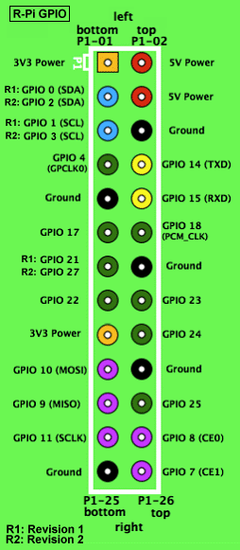 General-purpose input/output (GPIO) is a generic pin on an integrated circuit whose behavior, including whether it is an input or output pin, can be controlled by the user at run time.

GPIO capabilities may include:

* GPIO pins can be configured to be input or output
* GPIO pins can be enabled/disabled
* Input values are readable (typically high=1, low=0)
* Output values are writable/readable
* Input values can often be used as IRQs (typically for wakeup events)

The production Raspberry Pi board has a 26-pin 2.54 mm (100 mil) expansion header, marked as P1, arranged in a 2x13 strip. They provide 8 GPIO pins plus access to I²C, SPI, UART), as well as +3.3 V, +5 V and GND supply lines. Pin one is the pin in the first column and on the bottom row.

**Figure 2.1.4 GPIO connector on RPi**

* + 1. **DSI Connector**

The Display Serial Interface (DSI) is a specification by the Mobile Industry Processor Interface (MIPI) Alliance aimed at reducing the cost of display controllers in a mobile device. A DSI compatible LCD screen can be connected through the DSI connector, although it may require additional drivers to drive the display.

* + 1. **RCA Video**

RCA Video outputs (PAL and NTSC) are available on all models of Raspberry Pi. Any television or screen with a RCA jack can be connected with the RPi.

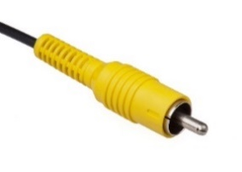

**Figure 2.1.6 RCA Video Connector**

* + 1. **Audio Jack**

A standard 3.5 mm TRS connector is available on the RPi for stereo audio output. Any headphone or 3.5mm audio cable can be connected directly. Although this jack cannot be used for taking audio input, USB mics or USB sound cards can be used.

* + 1. **Status LEDs**

There are 5 status LEDs on the RPi that show the status of various activities as follows:

“OK” - SD Card Access (via GPIO16) - labelled as "OK" on Model B Rev1.0 boards and "ACT" on Model B Rev2.0 and Model A boards

“POWER” - 3.3 V Power - labelled as "PWR" on all boards

“FDX” - Full Duplex (LAN) **(Model B)** - labelled as "FDX" on all boards

“LNK” - Link/Activity (LAN) **(Model B)** - labelled as "LNK" on all boards

“10M/100” - 10/100Mbit (LAN) **(Model B)** - labelled (incorrectly) as "10M" on Model B Rev1.0 boards and "100" on Model B Rev2.0 and Model A boards.

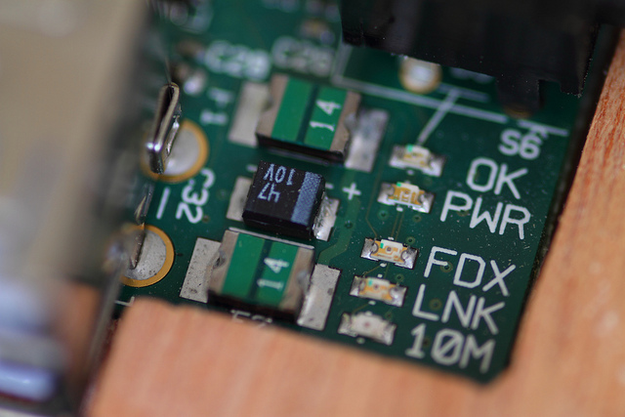

**Figure 2.1.8 Status LEDs**

* + 1. **USB 2.0 Port**

USB 2.0 ports are the means to connect accessories such as mouse or keyboard to the Raspberry Pi. There is 1 port on Model A, 2 on Model B and 4 on Model B+. The number of ports can be increased by using an external powered USB hub which is available as a standard Pi accessory.

* + 1. **Ethernet**

Ethernet port is available on Model B and B+. It can be connected to a network or internet using a standard LAN cable on the Ethernet port. The Ethernet ports are controlled by Microchip LAN9512 LAN controller chip.

* + 1. **CSI connector**

CSI – Camera Serial Interface is a serial interface designed by MIPI (Mobile Industry Processor Interface) alliance aimed at interfacing digital cameras with a mobile processor. The RPi foundation provides a camera specially made for the Pi which can be connected with the Pi using the CSI connector.

* + 1. **JTAG headers**

JTAG is an acronym for ‘Joint Test Action Group', an organization that started back in the mid 1980's to address test point access issues on PCB with surface mount devices. The organization devised a Many thousands of devices now include this standardized port as a feature to allow test and design engineers to access pins.

* + 1. **HDMI – High Definition Multimedia Interface**

HDMI 1.3 a type a port is provided on the RPi to connect with HDMI screens.

1. **WiFi Dongle**

Wireless-N USB adapter is used to connect Raspberry Pi with Internet. Standards are IEEE 802.11n, 802.11g, 802.11b and frequency range is 2.4 GHz. Its 150Mbps Nano USB adapter. Support the systems as XP, Vista, WIN 7, WIN 8, and Linux.

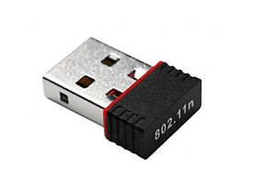

**Figure 2.2 WiFi Dongle**

1. **Raspberry Pi Camera**

The Raspberry Pi camera board contains a 5 MPixel sensor, and connects via a ribbon cable to the CSI connector on the Raspberry Pi. In Raspbian support can be enabled by the installing or upgrading to the latest version of the OS and then running Raspi-config and selecting the camera option. The cost of the camera module is 1600Rs. In India (10 May 2015) and supports 1080p, 720p, 640x480p video. The footprint dimensions are 25 mm x 20 mm x 9 mm. Since Raspberry Pi has a ready-to-use socket for camera cable, no extra cables or power supplies are needed.

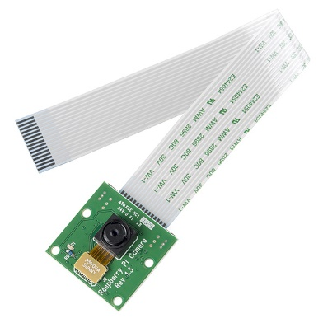

**Figure 2.3 Raspberry Pi Camera**

* 1. **5V Adapter Power Supply**

Raspberry Pi require power source to turn it on. 5V adapter Power supply is enough to power up. In project I connect Power bank with raspberry Pi, so that it can be put easily in structure.

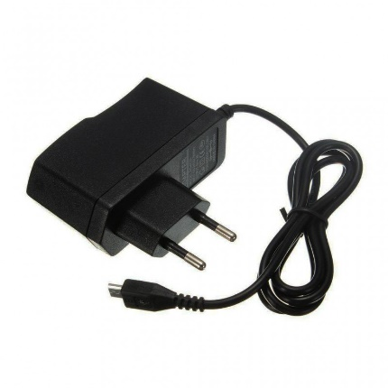

**Figure 2.4 5V Power Supply adapter**

* 1. **Ultrasonic Sensor**

This sensor is a high performance ultrasonic range finder. It is compact and measures an amazingly wide range from 2cm to 4m. This ranger is a perfect for any robotic application, or any other projects requiring accurate ranging information. This sensor can be connected directly to the digital I/O lines of your microcontroller and distance can be measured in time required for travelling of sound signal using simple formula as below. The module works on 5VDC input and also gives an output signal directly for detection of any obstacle up to 4M. As soon as the signals are transmitted the “Echo” pin goes to high level and remains in high level until the same sound waves are received by the receiver. If the received sound waves are same as what the same sensor transmitted then the Echo pin goes to low level. If no object is detected within 5M after 30ms the Echo signal will automatically go to low level.

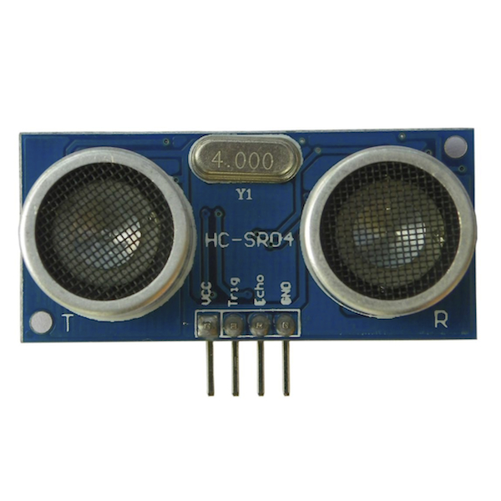

**Figure 2.5 Ultrasonic Module**

* 1. **IR Sensor**

The sensor consists of two eyes. One eye sends the infrared light and the other eye sees the reflection of that infrared light and measures the distance which is then sent to the Raspberry Pi to perform further operations based on the distance. There are three wires coming from the sensor. I.e. Red, Black and White or it can be Red, Brown and Yellow. Red is connected to 5V of Arduino. Black or brown to Ground of Arduino. White or yellow to analog input pin of Arduino i.e. in this case to analog pin 0.

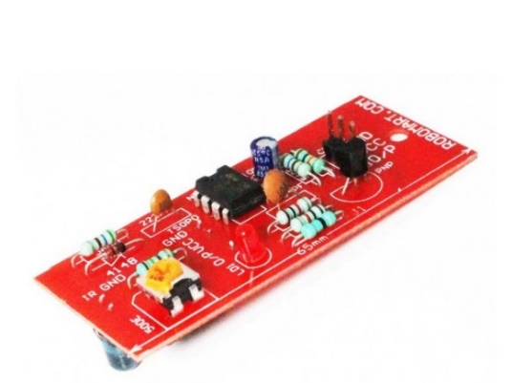

**Figure 2.6 IR Sensor**

* 1. **DC Motor**

Almost every mechanical movement that we see around us is accomplished by an electric motor. Electric machines are means of converting conventional energy. Motors take electrical energy and produce mechanical energy. Electric motor is used to power hundreds of devices we use in everyday life.

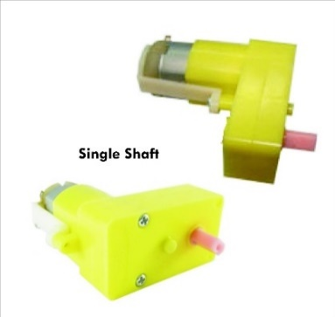

**Figure 2.7 2 DC Motor**

* 1. **L293D Motor Driver IC**

A very easy and safe is to use popular L293D chip. It is a 16- pin chip. The pin configuration of a L293D along with the behaviours of motor for different input conditions is given in fig. The L293D is designed to provide bidirectional drive currents of up to 600-mA at voltages from 4.5 V to 36 V. When an enable input is high, the associated drivers are enabled. Also their outputs are active and in phase with their inputs. When the enable input is low, those drivers are disabled, and their outputs are off and in the high-impedance state. With the proper data inputs, each pair of drivers forms a full-H (or bridge) reversible drive suitable for solenoid or motor applications. Design uses GPIO pins 2 and 3 to control the first motor and pins 4 and 5 to control the second motor. The 9V one battery will supply power for both of the motors, and Raspberry Pi will supply power for the motor control chips.

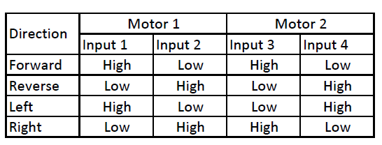

**Figure 2.8 Pin configuration of L293D**

**Table 2.8 Behaviours of motor for different input conditions**

The dc motor and L293D IC has been connected according to the fig. 9. The circuit schematic as shown has been designed using Proteus 7.

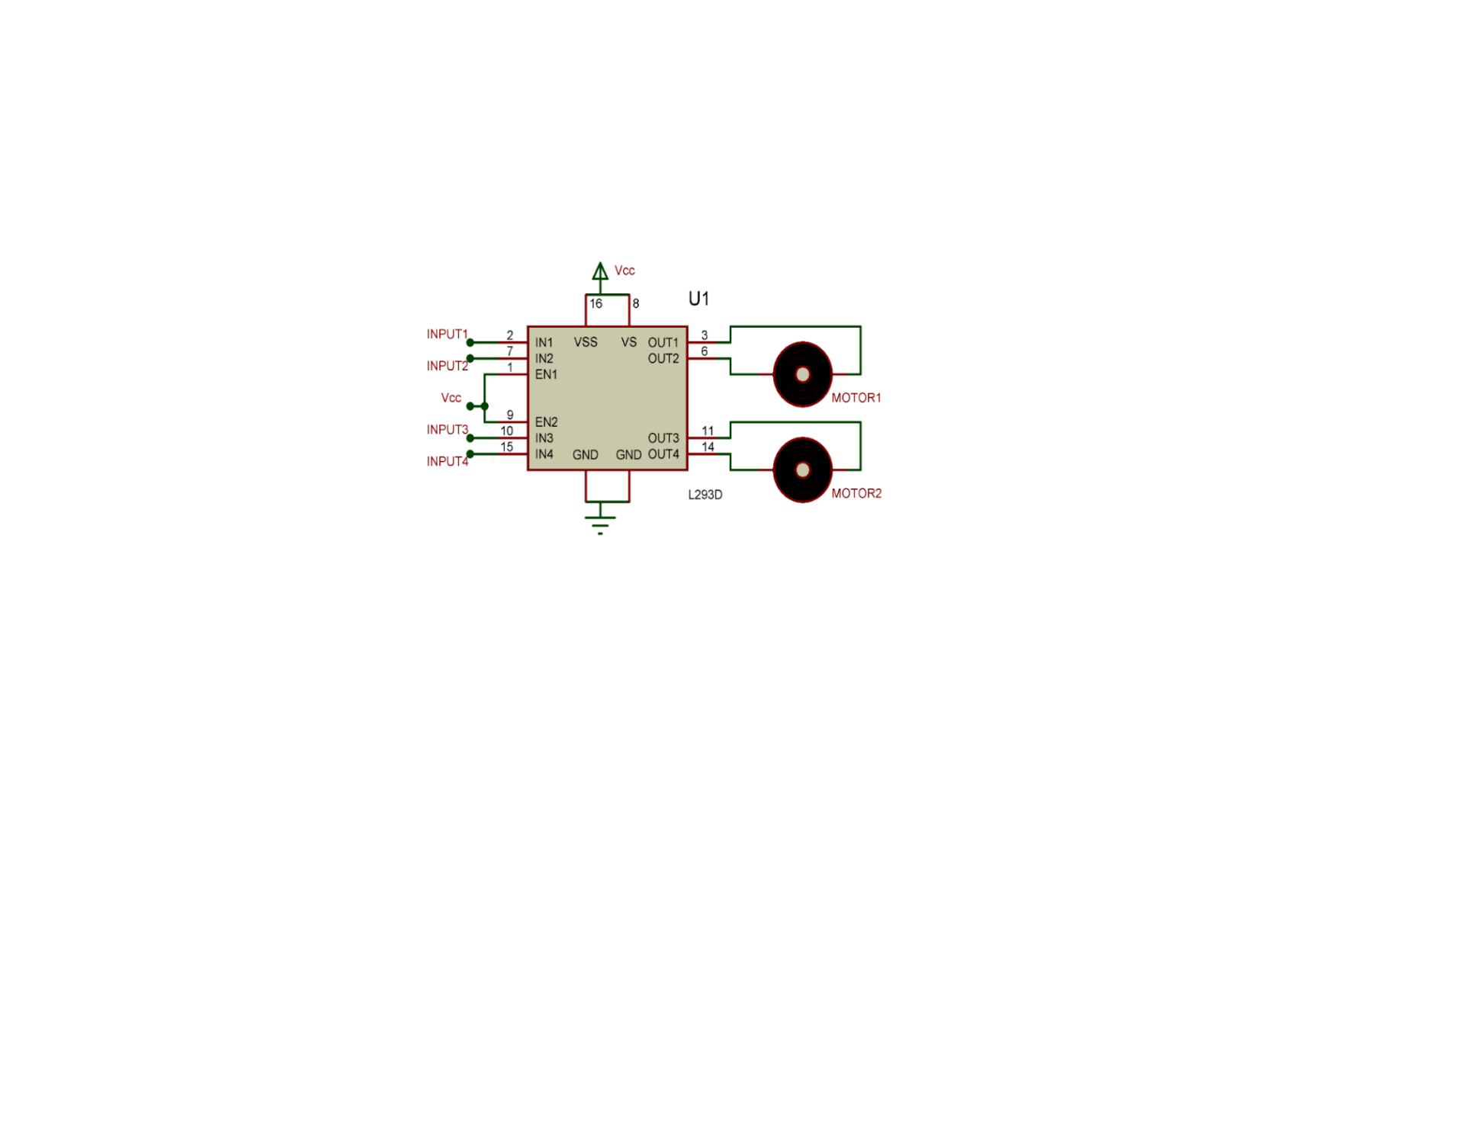

**Figure 2.8.1 3 Screenshot of DC motor and L293D IC interfacing circuit**

* 1. **Specifications of Different Raspberry PI Model**

Comparison of available Raspberry Pi Model with different parameters including its Price, Wight, Size and Power Source, etc.

|  |  |  |  |
| --- | --- | --- | --- |
|  | **Model A** | **Model B** | **Model B+** |
| **Target price:** | US$25 | US$35 | |
| **SoC:** | Broadcom BCM2835 (CPU, GPU, DSP, SDRAM, and single USB port) | | |
| **CPU:** | 700 MHz ARM1176JZF-S core | | |
| **GPU:** | Broadcom Video Core IV @ 250 MHz | | |
| **Memory (SDRAM):** | 256 MB | 512 MB | |
| **USB 2.0 ports:** | 1 | 2 | 4 |
| **Video input:** | 15-pin MIPI camera interface (CSI) connector | | |
| **Video outputs:** | 3.5 mm jack, HDMI ,raw LCD Panels | | |
| **Audio outputs:** | 3.5 mm jack, HDMI | | |
| **Onboard storage:** | SD / MMC / SDIO card slot | | MicroSD |
| **Onboard network:** | None | 10/100 Mbit/s Ethernet USB adapter | |
| **Low-level peripherals:** | 8× GPIO | | 17× GPIO |
| **Power ratings:** | 300 mA (1.5 W) | 700 mA (3.5 W) | 600 mA (3.0 W) |
| **Power source:** | 5 V via MicroUSB or GPIO header | | |
| **Size:** | 85.60 mm × 56 mm | | |
| **Weight:** | 45 g | | |

**Table 2.9 Specifications of Raspberry Pi different model**

## **Comparison of Raspberry with the competitors**

The chief competitors of the Raspberry Pi are the Arduino and the Beagleboard. Both are single board computers and have applications similar to the Raspberry Pi. A brief comparison of the three of them is shown below:

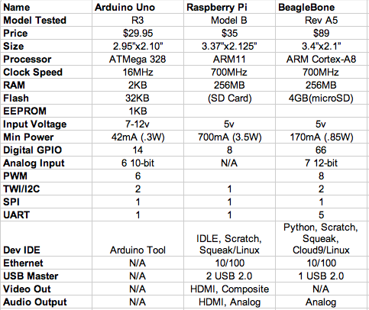

**Table 2.10 Comparison of RPi with chief competitors**

## **Advantages and disadvantages**

Advantages and disadvantages of Raspberry Pi from different aspect are described below:

* + 1. **Advantages of the Raspberry Pi**
* This microcomputer is useful for small or home based businesses that run on a smaller budget than bigger companies for you are not required to purchase any special licenses from the Raspberry Pi Foundation to use their product or if you invent new technology that embeds the product.
* The product does not require the user to have extensive programming experience since it is aimed for the younger generation to learn about programming. Python, the programming language that the Pi uses, is less complex than other languages available.
* The SD cards on the board can be easily switched, which allows you to change the functions of the device without spending a lot of time re-installing the software.
* The Raspberry Pi is perfect for adaptive technology: it is able to display images or play videos at 1080p high definition resolution. This product makes it possible to build complex and effective products at a cheaper price.
* This small credit card sized product makes it easy to recycle and does not release as much carbon dioxide emissions into the environment, unlike big servers that require lots of energy and extensive cooling systems.

### **Disadvantages**

* It does not replace your computer, since the Ethernet is only a 10/100 and the processor is not as fast, it is time consuming to download and install software and is unable to do any complex multitasking.
* Not compatible with other operating systems such as Windows (There are currently 1.3 billion Windows users around the world.)
* This product will not be useful for bigger businesses that already have big servers, which would already do everything that the Raspberry Pi does, so it would not be worth it to take the time to get someone to put it together.

Chapter-3 Software Implementation

It required number of Programming Tools & Languages to build a project. Eclipse Kepler, HTML/CSS, SERVLET/JSP, Java Script, JQuery, Ajax, MySQL database, Tomcat Web Server, MobaXtreme, WinSCP, and Putty.

1. **Eclipse Kepler**

**Eclipse** is an [integrated development environment](https://en.wikipedia.org/wiki/Integrated_development_environment) (IDE) used in [computer programming](https://en.wikipedia.org/wiki/Computer_programming). It contains a base [workspace](https://en.wikipedia.org/wiki/Workspace) and an extensible [plug-in](https://en.wikipedia.org/wiki/Plug-in_(computing)) system for customizing the environment. I used Eclipse Kepler and version 4.3.2.

**Figure 3.1 Eclipse**

1. **HTML/CSS**

**Hypertext Mark-up Language**, commonly abbreviated as **HTML**, is the standard [mark-up language](https://en.wikipedia.org/wiki/Markup_language) used to create [web pages](https://en.wikipedia.org/wiki/Web_page). Along with [CSS](https://en.wikipedia.org/wiki/Cascading_Style_Sheets), and [JavaScript](https://en.wikipedia.org/wiki/JavaScript), HTML is a cornerstone technology used to create web pages, as well as to create user interfaces for mobile and [web applications](https://en.wikipedia.org/wiki/Web_applications).

**Figure 3.2 HTML**

**Cascading Style Sheets** (**CSS**) is a [style sheet language](https://en.wikipedia.org/wiki/Style_sheet_language) used for describing the [presentation](https://en.wikipedia.org/wiki/Presentation_semantics) of a document written in a language. Although most often used to set the visual style of [web pages](https://en.wikipedia.org/wiki/Web_page) and user interfaces written in [HTML](https://en.wikipedia.org/wiki/HTML).

**Figure 3.2.1 CSS**

I used HTML and CSS both for the design of website and web page to control the Robot.

1. **JSP/Servlet**

**Java Server Pages (JSP)** technology enables Web developers and designers to rapidly develop and easily maintain, information-rich, dynamic Web pages that leverage existing business systems.

**Figure 3.3 JSP/Servlet**

Servlets are most often used to process or store a [Java class](https://en.wikipedia.org/wiki/Java_class) in [Java EE](https://en.wikipedia.org/wiki/Java_EE) that conforms to the Java Servlet API, a standard for implementing Java classes which respond to requests.

1. **Java Script**

**JavaScript**is a [high-level](https://en.wikipedia.org/wiki/High-level_programming_language), [dynamic](https://en.wikipedia.org/wiki/Dynamic_programming_language), [untipped](https://en.wikipedia.org/wiki/Programming_language#Type_system), and [interpreted](https://en.wikipedia.org/wiki/Interpreted_language) programming language. JavaScript's typing is [dynamic](https://en.wikipedia.org/wiki/Dynamic_typing). JavaScript is loaded as human-readable source code. JavaScript's are [prototype-based](https://en.wikipedia.org/wiki/Prototype-based_programming).

**Figure 3.4 Java Script**

1. **jQuery**

**JQuery** is a [cross-platform](https://en.wikipedia.org/wiki/Cross-platform) [JavaScript library](https://en.wikipedia.org/wiki/JavaScript_library) designed to simplify the [client-side scripting](https://en.wikipedia.org/wiki/Client-side_scripting) of [HTML](https://en.wikipedia.org/wiki/HTML). JQuery is the most popular JavaScript in use today. I am using version 2.2

**Figure 3.5 jQuery**

1. **Ajax**

**Ajax** is **asynchronous**[**JavaScript**](https://en.wikipedia.org/wiki/JavaScript)**and**[**XML**](https://en.wikipedia.org/wiki/XML)) is a set of [web development](https://en.wikipedia.org/wiki/Web_development) techniques using many web technologies on the [client-side](https://en.wikipedia.org/wiki/Client-side) to create [asynchronous](https://en.wikipedia.org/wiki/Asynchronous_I/O) [Web applications](https://en.wikipedia.org/wiki/Web_application). With Ajax, web applications can send data to and retrieve from a [server](https://en.wikipedia.org/wiki/Web_server) asynchronously (in the background) without interfering with the display and behavior of the existing page.

**Figure 3.6 Ajax**

When any button is pressed to control the robot, the whole page will not refresh and action is executed with the help of Ajax.

1. **MySQL**

**MySQL** is an [open-source](https://en.wikipedia.org/wiki/Open-source) [relational database management system](https://en.wikipedia.org/wiki/Relational_database_management_system). MySQL is a popular choice of database for use in web applications, and is a central component of the widely used LAMP open-source web application software stack. LAMP is an acronym for "[Linux](https://en.wikipedia.org/wiki/Linux), [Apache](https://en.wikipedia.org/wiki/Apache_HTTP_Server), MySQL, Perl/[PHP](https://en.wikipedia.org/wiki/PHP)/[Python](https://en.wikipedia.org/wiki/Python_(programming_language))".

**Figure 3.7 MySQL**

1. **Pi4j**

Pi4j is intended to provide a friendly object-oriented I/O API and implementation libraries for Java Language to access the full I/O capabilities of the Raspberry Pi platform. This project abstracts the low-level native integration and interrupt monitoring to enable Java programmers to focus on implementing their application business logic.

**Figure 3.8 Pi4j**

1. **Debian Raspberry PI Language**

**Debian** is a [Unix-like](https://en.wikipedia.org/wiki/Unix-like) computer [operating system](https://en.wikipedia.org/wiki/Operating_system) that is composed entirely of [free software](https://en.wikipedia.org/wiki/Free_software), most of which is under the [GNU General Public License](https://en.wikipedia.org/wiki/GNU_General_Public_License), and packaged by a group of individuals known as the Debian Project.  Raspbian Jessi Lite version 4.1 is installed in Raspberry Pi 2.

**Figure 3.9 4 Debian**

1. **Apache Tomcat**

Tomcat implements several [Java EE](https://en.wikipedia.org/wiki/Java_Platform,_Enterprise_Edition) specifications including [Java Servlet](https://en.wikipedia.org/wiki/Java_Servlet), [Java Server Pages](https://en.wikipedia.org/wiki/JavaServer_Pages) (JSP), [Java EL](https://en.wikipedia.org/wiki/Unified_Expression_Language), and [Web Socket](https://en.wikipedia.org/wiki/WebSocket), and provides a "pure [Java](https://en.wikipedia.org/wiki/Java_(programming_language))" [HTTP](https://en.wikipedia.org/wiki/Hypertext_Transfer_Protocol) [web server](https://en.wikipedia.org/wiki/Web_server) environment in which [Java](https://en.wikipedia.org/wiki/Java_(programming_language)) code can run. User have to install Apache in Eclipse and Raspberry Pi to run the java code. If the version is different and it will cause error to run different version Java code.

**Figure 3.10 Apache Tomcat**

1. **Linux**

**Linux** is a [Unix-like](https://en.wikipedia.org/wiki/Unix-like) and mostly [POSIX](https://en.wikipedia.org/wiki/POSIX)-complain computer [operating system](https://en.wikipedia.org/wiki/Operating_system) (OS) assembled under the model of [free and open-source software](https://en.wikipedia.org/wiki/Free_and_open-source_software) development and distribution.

**Figure 3.11 Linux**

1. **WinSCP**

**WinSCP** (*Windows Secure Copy*) is a [free and open-source](https://en.wikipedia.org/wiki/Free_and_open-source) [SFTP](https://en.wikipedia.org/wiki/SSH_file_transfer_protocol), [FTP](https://en.wikipedia.org/wiki/File_Transfer_Protocol), [WebDAV](https://en.wikipedia.org/wiki/WebDAV) and [SCP](https://en.wikipedia.org/wiki/Secure_copy) client for [Microsoft Windows](https://en.wikipedia.org/wiki/Microsoft_Windows). Its main function is secure file transfer between a local and a [remote computer](https://en.wikipedia.org/wiki/Remote_computer). Beyond this, WinSCP offers basic manager and [file synchronization](https://en.wikipedia.org/wiki/File_synchronization) functionality. For secure transfers, it uses Secure Shell ([SSH](https://en.wikipedia.org/wiki/Secure_shell)) and supports the SCP protocol in addition to SFTP. Raspberry Pi to Laptop file transfer WinSCP is used in project.

**Figure 3.12 WinSCP**

1. 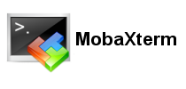**MobaXterm**

**MobaXterm** is your ultimate toolbox for remote computing. In a single Windows application, it provides loads of functions. Raspberry Pi is open in the MobaXterm application and it’s easier to open Remote Desktop or code in the Raspberry Pi.

**Figure 3.13 MobaXterm**

1. **Putty**

**Putty** is an SSH and telnet client, developed originally by Simon Tat ham for the Windows platform. Putty is open source software that is available with source code and is developed and supported by a group of volunteers. IP address of Raspberry Pi have to enter and raspberry pi is ready for programming.

**Figure 3.14 Putty**

Chapter-4 Implemented System

The system is implemented with Laser cutting tool and 3D printing tool. Robot chassis is designed with Laser cutting and Ultrasonic sensor and Camera case is designed with 3D priming.

Laser cutting machine is shown below and the full implemented chassis of robot.

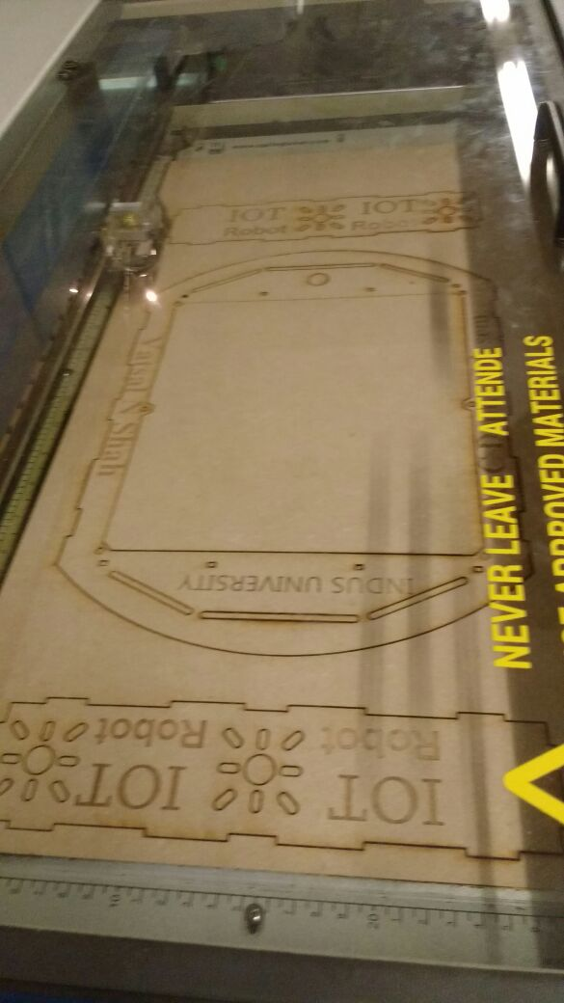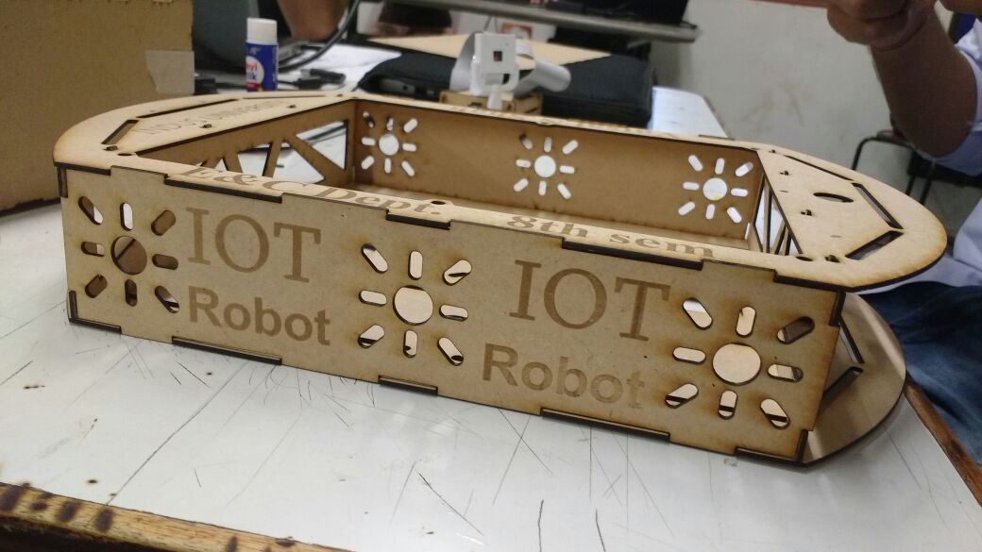

**Figure 4.1 Laser cut Chassis**

Using machine Ultimaker 2 case of Raspberry Pi camera is designed and working with it is shown below. The full body requires time around 1 hours to print it.

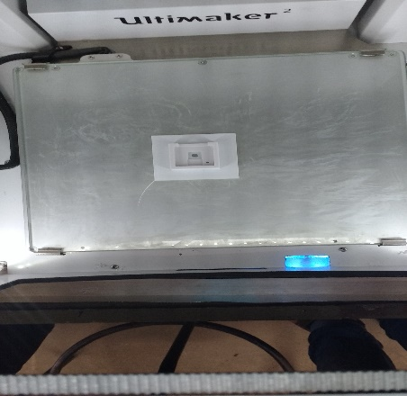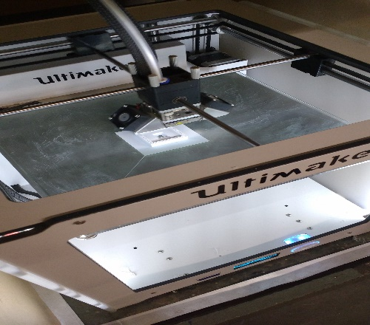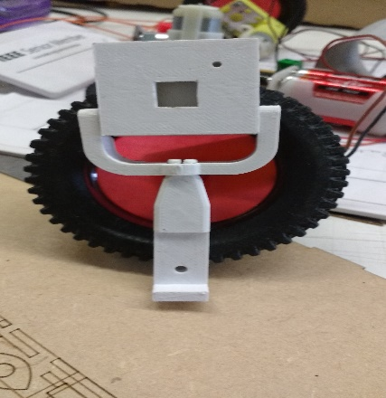

**Figure 4.1.1 3D printed Case**

Chapter-5 Results

The aim of the project is to develop a Robot on IoT based concept. It is working as buddy or family Member because you have to command it and control from anywhere at any time. If a personal wants to find something he/she has to command it from live steaming can see the actual scenario at that place and easily find out that object. It works as to take care for children’s, pet at home, too.

1. **Flow Chart**

The flow chart describe the necessary steps to execute once in the beginning, then when the Raspberry Pi turn on all the compilation files and video streaming file execute at its own using startup.sh file.

Login Fail

Successfully

**Figure 5.1 Flow Chart to Control Robot**

1. **Display of Website**

When a person enter IP address and open the website it shows as below:

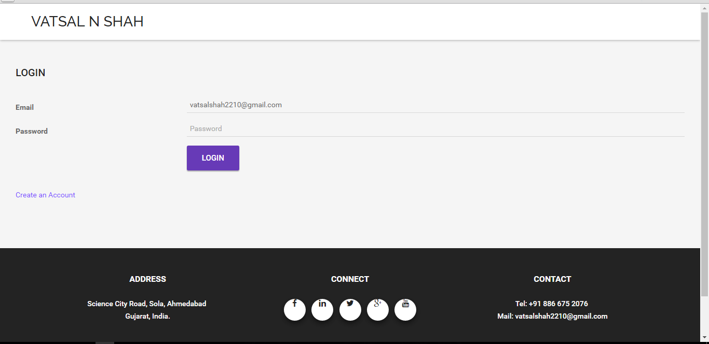

**Figure 5.2 Login Page for Robot Control**

Go to My Project tab and create an account and login successfully, the Robot Control screen will be show as below:

1



2

3

5

4

6

7

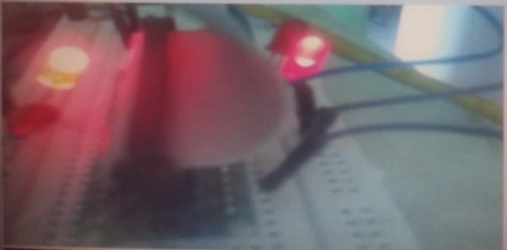

**Figure 5.2.1 Control page of Robot Control**

Carrying out unit test is kind of a pre-release of the system. Performing unit test in presence of supervisor ensures that final product had met all requirements. Unit test results listed described in below showing table:

|  |  |  |
| --- | --- | --- |
| **No.** | **Test case description** | **Test Result** |
| 1 | Webcam image display | Accepted |
| 2 | Move Forward | Accepted |
| 3 | Move Reverse | Accepted |
| 4 | Turn Left | Accepted |
| 5 | Turn Right | Accepted |
| 6 | Stop | Accepted |
| 7 | Ultrasonic sensor reading | Accepted |
| 8 | IR Sensor reading | Accepted |

**Table 5.2 Result set**

Final IoT Robot design is as shown below:

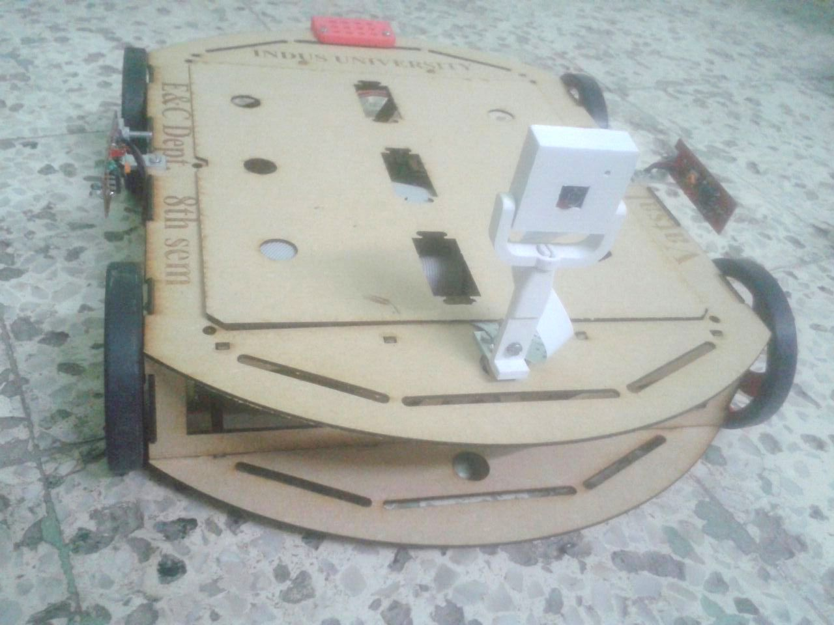

**Figure 5.2.2 IOT Robot Structure**

Chapter-6 Discussion / Conclusion / Future Work

## **Discussion**

During the whole period of the project I gained of lot of knowledge on the raspberry pi, motors and programming in java, MySQL. If we talk about the achievements out of the project when starting to do the project it was to control the motors using raspberry pi on a robot and transmit that data via any wireless technology to another device and able to collect the data and control the robot or raspberry pi in a real time instance. Out of which all the work was completed. The main achievements that I gained out of the project were that I got to learn programming in kava and could learn how to program a user interface web page. Another main achievement was I could learn and understand the raspberry pi technology, the wide applications of raspberry pi and IoT. There are lots of many other areas where the raspberry pi could be used for robotic applications and that are the reasons for me to choose this project.

1. **Conclusions**

To get to the aim of a project there will be always a set of objectives, to achieve that objectives we need to know how where and with what resource is the step towards completing the objectives taken. Now in this project too to get to the aim of the project there was a set of objectives, which gradually changed as the project research was completed and then while testing a certain technology the objectives again changed due to the failure of the method. Now the first thing of the project is a good research, I had to do a wide and a strong research before I started to put my objectives as this technology was new in market.

The research for the project was done using Advanced Google search and also from the search engines available in the student portal like tutorials, pi4j, w3school and raspberry pi.

The Google advanced search is the one that was more widely used as it is a new technology and there are very less articles or journals published regarding the raspberry pi technology and IoT.

Each stage of the project was tested after every part of it was completed and then moved on to the next one. During the course of the project I gained knowledge of Java I also gained knowledge of the raspberry pi technology and what the small computer is capable of. After knowing the capabilities of raspberry pi and the applications it could have in the field of robotics, and IoT it actually has made me to think of doing more research work on the raspberry pi for the robotic and IoT applications.

The challenges that I faced during the course of the project were that of the time constrain, as I had to learn about the raspberry pi and then learn programming in Java and HTML. Then during the programming of the server client interfaces the problems of calling functions with a button press. One of the main challenges that No output comes when some functions are called from software side. Other than the small problem the buddy robot works fine and meets all its purpose.

If given an opportunity to work again on the same technology i.e. the raspberry pi and IoT technology or on a project like this where the raspberry pi is used for any kind off application I would be happy to take it up.

1. **Future Work**

In the future this raspberry pi technology can be used in various different fields of work. The buddy robot can be made autonomous with the help of more sensor, gyroscope, compass and a GPS. So that it can be set to a target or a specific area where in can monitor. The robot can also be developed into an advanced robot toy for young people. Others future works described below:

* Face recognition: All the family members face images are stored in controller when an unknown person will come at door, it will create alert and click the image and send it to user.
* In changing the Mechanical design work using the same concept, different functions as Open the door, Turn on/off switch, bring newspaper for user, etc work can be done.
* Adding the Pneumatics design in Mechanical design robot can walk, go up and down and it will be control from anywhere at any time.

# **References**

1. About Raspberry Pi, http://www.raspberrypi.org/about/
2. Early prototype of Raspberry Pi, http://www.raspberrypi.org/raspberry-pi-2006-edition/
3. Raspberry Pi Hardware information, http://elinux.org/RPi_Hardware
4. How SoC works, http://www.androidauthority.com/how-it-works-systems-on-a-chip-soc-93587/
5. Boot process, http://thekandyancode.wordpress.com/2013/09/21/how-the-raspberry-pi-boots-up/
6. List of available OS, http://elinux.org/RPi_Distributions
7. Home automation project, http://www.instructables.com/id/Raspberry-Pi-GPIO-home-automation
8. Arcade gaming machine project, http://www.cnet.com/how-to/25-fun-things-to-do-with-a-raspberry-pi/
9. Robot project, http://www.wired.com/2013/01/raspberry-pi-r2d2/
10. Landline telephone project, https://www.twilio.com/blog/2013/03/build-a-twilio-hard-phone-with-sip-from-twilio-raspberry-pi-asterisk-freepbx-and-the-obihai-obi100.html
11. Decoration lights project, http://www.element14.com/community/community/raspberry-pi/raspberrypi_projects/blog/2013/12/12/raspberry-pi-enabled-christmas-lights
12. Advantages-Disadvantages, https://sites.google.com/site/mis237groupprojectraspberrypi/home/what-is-raspberry-pi/pros-and-cons-of-the-raspberry-pi
13. JavaScript for webpage, https://www.codecademy.com/learn/javascript
14. Ajax learn, http://www.w3schools.com/ajax/
15. HTML for webpage, <http://www.tutorialspoint.com/html/>
16. About Apache, <http://tomcat.apache.org/>
17. MySQL Database, <http://dev.mysql.com/downloads/>
18. MobaXteme, <http://mobaxterm.mobatek.net/>
19. Design and build a Raspberry Pi robot By Stewart Watkiss, (PenguinTutor)
20. Rasp-Pi based Remote Controlled Smart Advertising of Still and Moving Images, International Journal of Engineering and Computer Science, Volume 4 Issue 9 Sep 2015.
21. Build and Interface Internet Mobile Robot using Raspberry Pi and Arduino by Prof. Dr. Nabeel Kadim Abid Al-Sahi, Innovative Systems Design and Engineering Vol.6, No.1, 2015